# **1. TEAM PROFILE**

## **1.1. Team Name**

Our team’s name is Spotifour. All four members of our team love listening to music with Spotify - a digital music streaming service and the technologies behind this incredible app. Moreover, our group has four people, so we decided to mix Spotify (name of a digital music streaming service) and Four together to get Spotifour. In this project, we also want to create a web application for people to enjoy listening to their favourite sounds and music. Spotifour is the perfect name for representing our passions and upcoming projects.

## **1.2. Personal Information**

**VU TUAN LINH**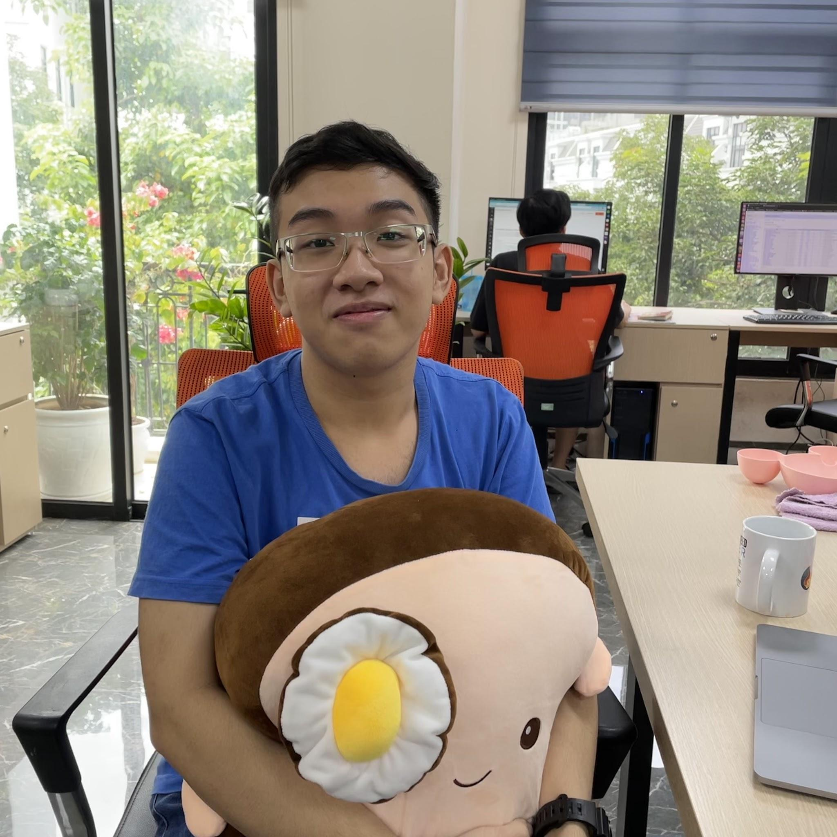

My name is Vu Tuan Linh, my student number is s3927502, and my university email is s3927502@rmit.edu.vn. Chemistry was my specialty in the Hanoi-Amsterdam High School for Gifted Students. However, after graduating from high school, I recognized that information technology was my actual calling. As a result, I opted to pursue my first job as a web developer for a small software firm, where I worked for a year before returning to RMIT to continue my studies. I consider myself to be a lifelong student. As a result, I'm constantly keen to learn new technologies and put them into practice as quickly as feasible, usually through a personal project. I also enjoy reading nonfiction books and frequently write (in Vietnamese) and publish pieces on my own blog. It's where I share my experience and advice with readers in order to help them be more productive and live a healthier lifestyle. Since high school, I've been attracted by the rapid expansion of IT applications. My interest in this topic has grown as a result of reading about the founders of significant computer firms, particularly Steve Jobs' story of founding Apple from his garage. In terms of IT, I'm particularly interested in web and app development. As a result, after graduating from high school, I opted to start working as a web developer. My coding and teamwork abilities have improved dramatically after a year of working with my team to produce sophisticated e-commerce websites.

**DAU HOANG MINH**

My student number is s3926201, and my name is Dau Hoang Minh. I enjoy listening to music, playing board games, and being involved in charitable and environmental organizations. I've had an interest in computers since I was a youngster. My sister was studying for a "Master of Information Technology" when I was a kid, and I used to pester her with IT inquiries. My sister then went through some fundamental IT words with me, such as the Internet, applications, hacking, data storage, and so on. For me, the computer was a magnificent object that had a whole new universe within it at the moment. I was given the opportunity to learn the Python programming language in high school. Although most of my classmates are uninterested in this topic, I find myself very lucky to have this fascinating opportunity. I also represented my school in a tiny hackathon called "Hello World," where my team placed in the top five of the most successful teams. As a result of those experiences, I got a lot more confident in my abilities to study this area. Therefore, I chose RMIT University to pursue a "Bachelor of Information Technology."

**DANG THAI HOANG**

My student number is s3927234, and my name is Dang Thai Hoang. My friends frequently use the terms "friendly" and "hilarious" to describe me. I enjoy learning many topics, including design, art, and science. Music is also a big passion of my life, both listening to it and playing it. Since I was a small child, I've always been a wicked kid who has always wanted to learn new things, especially about technology. My father and I spent a lot of time together trying to figure out topics like "What is inside a computer?" "How does a touch-screen work?" and "How does a website work?". I fell in love with this topic of study and hoped that I would be able to learn more about it in the future. At the moment, I am very proud to be a student at the Royal Melbourne Institute of Technology (RMIT) University, where I am majoring in Information Technology (IT). I've learned programming fundamentals so far using languages like Python, HTML, and CSS. Furthermore, I am familiar with basic UI and UX ideas by spending a few years developing logos and retouching photos. Learning at RMIT, I was fortunate enough to be assigned to a team of talented individuals; we are all IT enthusiasts who constantly go out of our way to assist one another. We are Spotifour!

**LE TRINH QUOC HUYNH**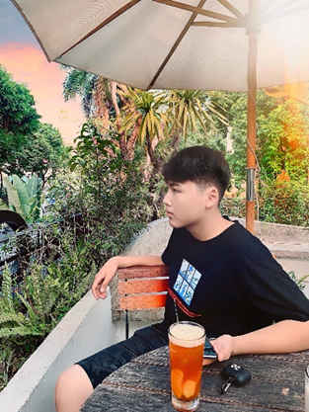

I am Le Trinh Quoc Huynh, my student number is s3925997, and my email is s3925997@rmit.edu.vn. I was born in Hanoi, Vietnam's capital city. I can understand how Vietnamese culture has evolved through time since I live in an extended family. Unlike many other Vietnamese families, my parents do not encourage me to study hard or obtain straight A's in school; instead, they want me to be self-aware and fully accountable for my studies. In addition to my mother tongue, I am also proficient in English. I've always wanted to study Chinese but have never had the opportunity. Physical activities and computer games do not stimulate me. Therefore, I spend most of my time listening to music. Opera is one of my favourite musical genres, and while it is popular in many European nations, few Vietnamese people love listening to it. Despite my passion for technology, I understood very little about programming or coding until I started high school. Ta Quang Buu High School was where I spent three years of my life. We were able to study a topic known as "STEM," which stands for "Science, Technology, Engineering, and Mathematics." Teachers showed us how to put together various scientific projects. However, my interest in technology was sparked by a competition where I paired up with a buddy to compete in a Scientific Contest organized by the Hanoi Department of Education and Training. We created a system that monitors the water environment in real-time. Nonetheless, as high school students, we lacked the necessary understanding to build such a complex project. Consequently, we learned a lot about coding, utilizing and calibrating sensors, etc.

## **1.3 Group Processes**

In general, our group worked quite fluently on this assignment. We formed a team and decided on the project idea very early. We anticipated that the volume of work for assignment three would be enormous, so after completing assignment 2, we began planning all of the tasks and conducting research on each section's requirements. However, most of our team members have no prior experience developing websites using various programming languages such as HTML, CSS, or JavaScript. As a result, we must devote a significant amount of time to learning those skills and becoming familiar with code editors and project management applications. Fortunately, we were able to finish the assignment on time, correct grammatical errors, and check the similarity score before submitting the report.

In the future, we should broaden our IT knowledge and select a code editor that we find convenient to use. As a result, we could save a lot of time completing the project idea and focusing more on the presentation. Another thing to improve is to divide tasks more clearly. When we work, we simply assign tasks to each member without establishing a clear deadline for completion, resulting in a minority of tasks being done late. Several tasks were dependent on the completion of previous ones to keep things running smoothly, so finishing tasks late really slowed down the flow of work. We should improve this aspect in the following assignments to maximize productivity.

## **1.4. Career Plans**

Since we are all majoring in Information Technology, we all aim to work in the IT industry, especially in two aspects: Web Development and Artificial Intelligence. However, our ideal jobs appear to be quite different from each other.

Tuan Linh's ideal job is becoming a full-stack engineer working with machine learning data infrastructure. He always liked creating frontends for websites that provide a fantastic user interface/experience and integrate with the logic in the backend and database. Surprisingly, Minh and Hoang's ideal jobs were quite the same. They both want to work with websites. While Minh intends to become a Web Developer, Hoang's perfect position is a Frontend Developer. Web Developers will be responsible for building and modifying websites and contributing to the test plan and design by developing unit test cases. As a Frontend Developer, it is Hoang's responsibility to create user interfaces and interactive aspects for the website and application. In contrast, Huynh's ideal job is quite different from other teammates'. He wants to become an AI Manager. Furthermore, he will also assist in the selection of associated technologies for developing AI/ Machine Learning models and take part in creating methods for implementing AI projects and products (ML model development lifecycle) using Deep Learning, Computer Vision, and Machine Learning methodologies.

Each person's plan to achieve their dream is different, and everyone has their way of getting what they want. As we are currently freshmen at RMIT, our first goal is to complete the current program and get the "Bachelor of Information Technology" degree.

During those three years, Minh and Hoang want to take advantage of all available possibilities to further their knowledge of IT, notably software programming and cloud computing. They will read new texts at the basic and intermediate levels and enroll in various online courses to improve their understanding of numerous programming languages. Minh plans to start by learning Python and JavaScript and then go to Java and HTML & CSS. Meanwhile, Linh intends to continue strengthening his expertise in frontend development and learn new programming languages by taking online courses in Udemy or Linkedin Learning in his free time. If it is possible, in the future, Hoang would like to join the SAS Tutor team, so not only can he help others with their study but also it is a good chance for him to structure his knowledge and understanding in IT field. For Huynh, to obtain experience, he will apply for an internship or work in an AI agency. In addition, Huynh will take external Deep Learning and Big Data classes because the company needs applicants to have an in-depth understanding of AI, Big Data and Machine Learning. Because AI is a field that necessitates a high level of expertise, he would consider pursuing a master's or doctorate degree in Australia.